INDIAN SCHOOL AL WADI AL KABIR
DEPARTMENT OF SOCIAL SCIENCE
MID TERM ASSESSMENT : 2023-24
Class: VIII Time Allowed :2½Hour
Date: 19-09-2023 Max: Marks: 80
General Instructions: -
1. Ensure that you have written your name and roll number correctly.
2. This Question paper has three parts, Section A (History)B (Civics) C (Geography).
3. All questions are compulsory.
4. Detach the map from the question paper and tie it along with your answer script.
5. All the answers must be correctly numbered as in the question paper in the Answer sheet
provided.

 | SECTION - A (HISTORY) 10 Marks
I | Choose the correct answer: - | 5 marks
1 | Who was the first Governor general in India?  a) Warren Hastings b) Ripon c) Harding d) Lytton | 1 mark
2 | Census were held at the interval of every  a) five years b) four years c) seven years d) ten years | 1 mark
3 | The British thought ______ were important for the effective administration  a) Census b) Surveys c) Achieves d) Official records | 1 mark
4 | Gomasthas were the agents of the  a) Planters (b) Industries (c) Factories (d) Farmers | 1 mark
5 | Where did the Sepoy mutiny primarily begin in 1857?  (a)Meerut (b)Kanpur (c)Jhansi (d)None of these. | 1 mark
II | Fill in the blanks: - | 3 marks
6 | Bigha was the unit of ________ measurement in Bengal. | 1 mark
7 | History is about finding out how things were in the past and how things have been _____________. | 1 mark
8 | __________ was the adopted son of Peshwa Baji Rao II. | 1 mark
III | Match the following: -  Column A Column B  9 Governor General A Birjis Qadr  10 Ryoti B Village  11 Begum Hazrat Mahal C Farmer  12 Mahal D Lord Dalhousie  E Cultivation on ryot’s lands | 4 marks
IV | Answer the following: - | 6 marks
13 | What is the problem with the periodization of Indian history that James Mill offers? | 2 marks
14 | Give two problems which arose with the new Munro system of fixing revenue. | 2 marks
15 | How did the last Mughal emperor live in his last years of life? | 2 marks
V | Answer in brief: - | 9 marks
16 | Observe the following picture and answer the questions below.  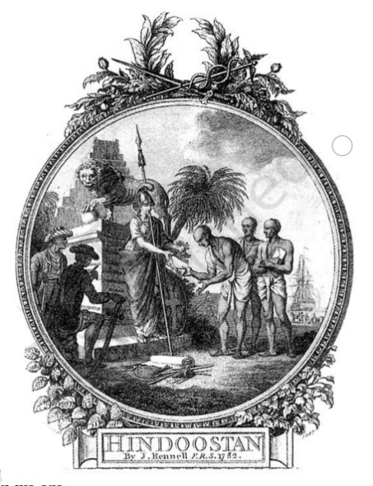  a). What does the above picture try to suggest?  b). Explain how this image projects an imperial perception.  c). What does the term ‘imperial perception’ mean? | 3 marks  1 mark  1 mark  1 mark
17 | What were the drawbacks of ‘Nij’ cultivation? | 3 marks
18 | What were the measures taken by the British to reform Indian Society? | 3 marks
VI | Read the passage carefully and answer the questions that follow: - | 3 marks
19 | The British had not expected this to happen. They thought the disturbance  caused by the issue of the cartridges would die down. But Bahadur Shah  Zafar’s decision to bless the rebellion changed the entire situation  dramatically. Often when people see an alternative possibility they feel  inspired and enthused. It gives them the courage, hope and confidence to  act  - What did the British think regarding the disturbance caused by the issue of cartridges?  - What was the impact of Bahadur Shah Zafar's decision to bless the rebellion?  - What demand did the ageing emperor have to accept? | 1 mark  1 mark  1mark
VII | Answer in detail: - | 5 Marks
20 | Describe the main features of the Permanent Settlement.  OR  What were the main features of the ‘Ryoti’ system of cultivation? | 5marks
VIII | On the given outline Map of India, Identify and name the territories marked A, B, C, D and E | 5 marks
 | SECTION - B (CIVICS) 20 Marks
IX | Choose the correct answer: - | 5 marks
21 | _________ refers to the existence of more than one level of government in a country.  - Secularism b) Federalism c) Unitary d) None of these | 1 mark
22 | Who was the President of the Constituent Assembly of India?  a) Dr. Rajendra Prasad. b) Jawaharlal Nehru. c) Dr. John Mathai. d) Shri Jagjivan Ram | 1 mark
23 | What was the demand of the Indian National Congress in 1935?  a) Constituent Assembly b) Constitution Assembly c) Conventional  Assembly d) none of these | 1 mark
24 | Which is an important way to control the executive in Parliament?  a) Assembly b) Zero-hour c) Question hour d) none of these | 1 mark
25 | Representatives to the Indian Parliament is chosen by the  a) People b) Prime Minister c) President d) None of these | 1 mark
X | Fill in the blanks: - | 3 marks
26 | A written document in which we find the rules formulated through conscience is called as _______________ | 1 mark
27 | ______________ protects the Fundamental Rights of the people in India. | 1 mark
28 | All the representatives in the Parliament together control and guide the ___________ . | 1 mark
XI | Answer the following: - | 4 marks
29 | What would happen if there were no restrictions on the power of elected representatives? | 2 marks
30 | Why Laws are important in a country?
XII | Answer in brief: - | 3 marks
31 | Why do you think our national movement supported the idea that all adults should have a right to vote? | 3 marks
XIII | Answer in detail: - | 5 marks
32 | How is the national government formed? | 5 marks
 | SECTION - C (GEOGRAPHY) 20 Marks
XIV | Choose the correct answer: - | 3 marks
1 | Which one of the following is a human-made resource?  (a) Medicines to treat cancer (b) Spring water (c) Tropical forests (d) None of these | 1 mark
2 | High speed winds, solar energy, bio waste etc. were all considered as potential sources of energy in the past, but today they are all examples of -  a) Non-Renewable Resources b) ubiquitous Resources c) Actual Resources  d) Localized Resources | 1 mark
3 | Coal is an example of:  a) Renewable resources b) Non-renewable resources c) Solar power  d) Human resources | 1 mark
XV | Match the following: -  Column A Column B  4 Resource A Renewable resource  5 Tundra vegetation B Coastal and dry regions  6 Windmill C Utility  7 Shelter belts D Kaziranga park  E Mosses and Lichens | 4 marks
XVI | Answer the following: - | 2 marks
8 | What is a “Resource”? How resources are generally classified? | 2 marks
XVII | Answer in brief: - | 6 marks
9 | “Human resources have an important entity”, Give reasons. | 3 marks
10 | Draw and label the diagram of Soil Profile. | 3 marks
XVIII | Answer in detail: - | 5 marks
11 | Define ‘soil’. Suggest some measure to make the soil fertile? | 5 marks

